Module 2: An Android Application Design Essential
Creating Android Applications
In this chapter we will concentrate on the specialties in creating any Android-Application.

Anatomy of an Android Application
There are four building blocks to an Android application:
• Activity
• Intent Receiver
• Service
• Content Provider
Not every application needs to have all four, but your application will be written with some combination of these.
Once you have decided what components you need for your application, you should list them in a file called AndroidManifest.xml. This is an XML file where you declare the components of your application and what their capabilities and requirements are. We will discuss soon, what the AndroidManifest.xml is responsible for.
Activity
Activities are the most common of the four Android building blocks. An activity is usually a single screen in your application. Each activity is implemented as a single class that extends the Activity base class. Your class will display a user interface composed of Views and respond to events. Most applications consist of multiple screens. For example, a text messaging application might have one screen that shows a list of contacts to send messages to, a second screen to write the message to the chosen contact, and other screens to review old messages or change settings. Each of these screens would be implemented as an activity. Moving to another screen is accomplished by a starting a new activity. In some cases an Activity may return a value to the previous activity - for example an activity that lets the user pick a photo would return the chosen photo to the caller.
When a new screen opens, the previous screen is paused and put onto a history stack. The user can navigate backward through previously opened screens in the history. Screens can also choose to be removed from the history stack when it would be inappropriate for them to remain. Android retains history stacks for each application launched from the home screen.
Intent and Intent Filters
Android uses a special class called Intent to move from screen to screen. Intent describe what an application wants done. The two most important parts of the intent data structure are the action and the data to act upon. Typical values for action are MAIN (the front door of the application), VIEW, PICK, EDIT, etc. The data is expressed as a Uniform Resource Indicator (URI). For example, to view a website in the browser, you would create an Intent with the VIEW action and the data set to a Website-URI.
new Intent(android.content.Intent.VIEW_ACTION, ContentURI.create("http://anddev.org"));There is a related class called an IntentFilter. While an intent is effectively a request to do something, an intent filter is a description of what intents an activity (or intent receiver, see below) is capable of handling. An activity that is able to display contact information for a person would publish an IntentFilter that said that it knows how to handle the action VIEW when applied to data representing a person. Activities publish their IntentFilters in the AndroidManifest.xml file.
Navigating from screen to screen is accomplished by resolving intents. To navigate forward, an activity calls startActivity(myIntent). The system then looks at the intent filters for all installed applications and picks the activity whose intent filters best matches myIntent. The new activity is informed of the intent, which causes it to be launched. The process of resolving intents happens at run time when startActivity is called, which offers two key benefits:
 Activities can reuse functionality from other components simply by making a request in the form of an Intent
. Activities can be replaced at any time by a new Activity with an equivalent IntentFilter
Intent Receiver
You can use an IntentReceiver when you want code in your application to execute in reaction to an external event, for example, when the phone rings, or when the data network is available, or when it's midnight. Intent receivers do not display a UI, although they may display Notifications to alert the user if something interesting has happened. Intent receivers are also registered in AndroidManifest.xml, but you can also register them from code using Context.registerReceiver(). Your application does not have to be running for its intent receivers to be called; the system will start your application, if necessary, when an intent receiver is triggered. Applications can also send their own intent broadcasts to others with Context.broadcastIntent().

Service
A Service is code that is long-lived and runs without a UI. A good example of this is a media player playing songs from a play list. In a media player application, there would probably be one or more activities that allow the user to choose songs and start playing them. However, the music playback itself should not be handled by an activity because the user will expect the music to keep playing even after navigating to a new screen. In this case, the media player activity could start a service using Context.startService() to run in the background to keep the music going. The system will then keep the music playback service running until it has finished. (You can learn more about the priority given to services in the system by reading Life Cycle of an Android Application.) Note that you can connect to a service (and start it if it's not already running) with the Context.bindService() method. When connected to a service, you can communicate with it through an interface exposed by the service. For the music service, this might allow you to pause, rewind, etc.
Content Provider
Applications can store their data in files, a SQLite database, preferences or any other mechanism that makes sense. A content provider, however, is useful if you want your application's data to be shared with other applications. A content provider is a class that implements a standard set of methods to let other applications store and retrieve the type of data that is handled by that content provider.

2-Defining Your Application Using the Android Manifest File
Android projects use a special configuration file called the Android manifest file to determine application settings—settings such as the application name and version, as well as what permissions the application requires to run and what application components it is comprised of. In this chapter, you explore the Android manifest file in detail and learn how different applications use it to define and describe application behavior.

Configuring the Android Manifest File
The Android application manifest file is a specially formatted XML file that must accompany each Android application.This file contains important information about the application’s identity. Here you define the application’s name and version information and what application components the application relies upon, what permissions the application requires to run, and other application configuration information.
The Android manifest file is named AndroidManifest.xml and must be included at the top level of any Android project.The information in this file is used by the Android system to
- Install and upgrade the application package.
- Display the application details such as the application name,
description, and icon to users.
- Specify application system requirements, including which Android SDKs are supported, what hardware configurations are required (for example, d-pad navigation), and which platform features the application relies upon (for example, uses multitouch capabilities).
- Launch application activities.
- Manage application permissions.
- Configure other advanced application configuration details, including acting as a service, broadcast receiver, or content provider.
- Enable application settings such as debugging and configuring instrumentation for application testing.

Editing the Android Manifest File
The manifest resides at the top level of your Android project.You can edit the Android manifest file using the Eclipse Manifest File resource editor (a feature of the Android ADT plug-in for Eclipse) or by manually editing the XML.

Editing the Manifest File Using Eclipse
You can use the Eclipse Manifest File resource editor to edit the project manifest file.The Eclipse Manifest File resource editor organizes the manifest information into categories:
The Manifest tab
The Application tab
The Permissions tab
The Instrumentation tab
The AndroidManifest.xml tab
Let’s take a closer look at a sample Android manifest file.The figures and samples come from the Android application called Multimedia,Using Android Multimedia APIs.”We chose this project because it illustrates a number of different characteristics of the Android manifest file, as opposed to the very simple default manifest file you configured for the MyFirstAndroidApp project.

Configuring Package-Wide Settings Using the Manifest Tab
The Manifest tab contains package-wide settings, including the package name, version information, and supported Android SDK information.You can also set any hardware or feature requirements here.
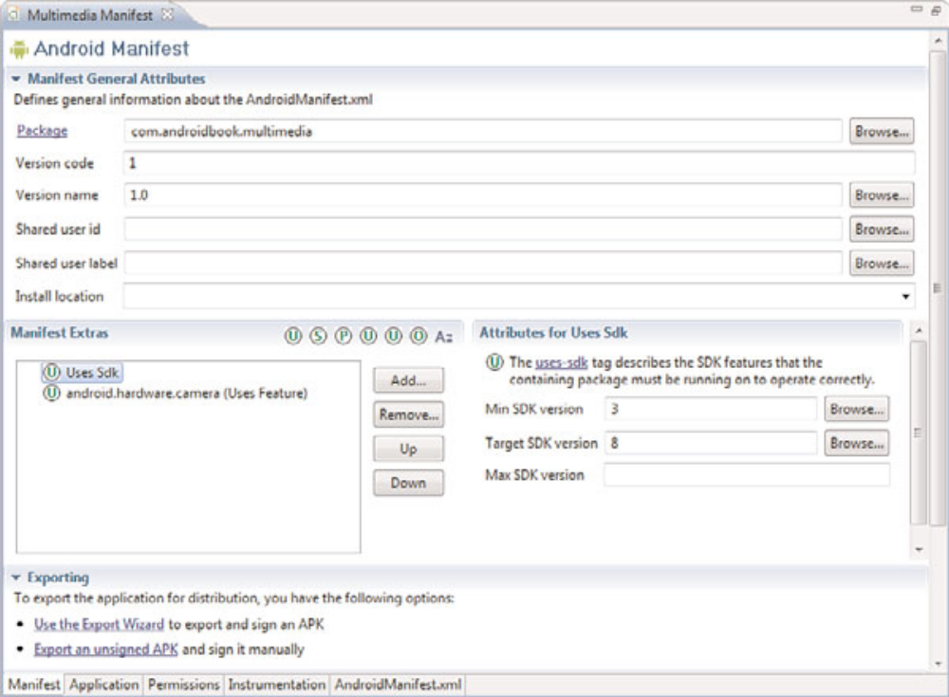

Managing Application and Activity Settings Using the Application Tab
The Application tab (see Figure 5.2) contains application-wide settings, including the application label and icon, as well as information about the application components such as activities, intent filters, and other application components, including configuration for services, intent filters, and content providers.

Enforcing Application Permissions Using the Permissions Tab
The Permissions tab (see Figure 5.3) contains any permission rules required by your application. This tab can also be used to enforce custom permissions created for the application.

Managing Test Instrumentation Using the Instrumentation Tab
The Instrumentation tab allows the developer to declare any instrumentation classes for monitoring the application.We talk more about instrumentation and Testing Android Applications.”
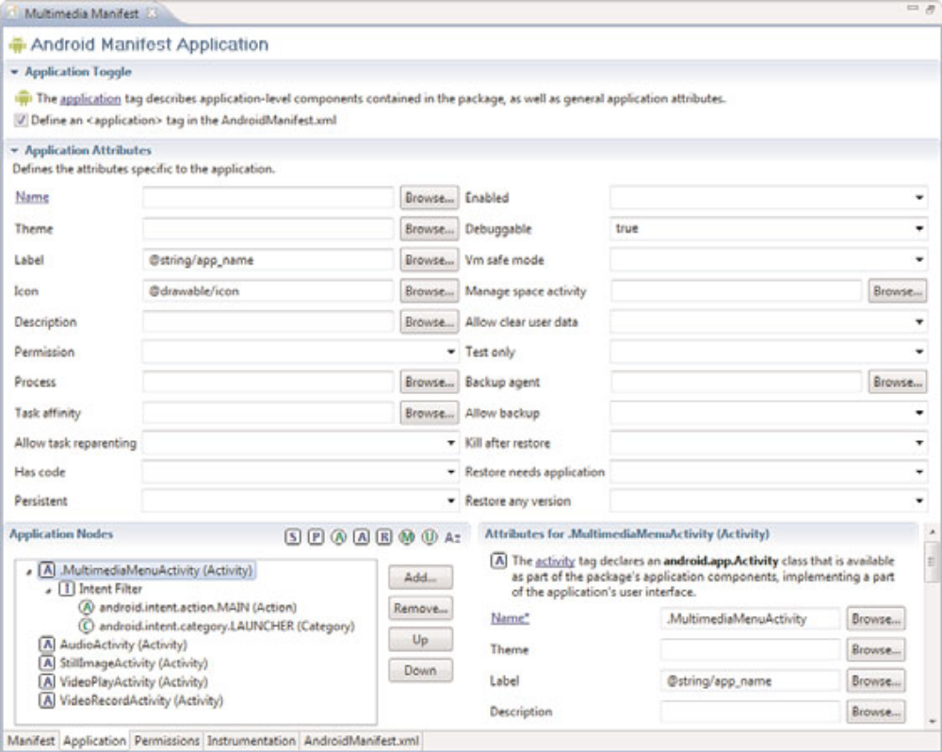
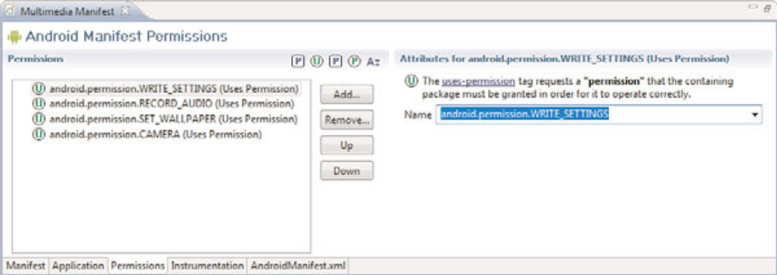

Editing the Manifest File Manually
The Android manifest file is a specially formatted XML file.You can edit the XML manually by clicking on the AndroidManifest.xml tab.
Android manifest files generally include a single <manifest> tag with a single <application> tag.The following is a sample AndroidManifest.xml file for an application called Multimedia

<?xml version="1.0" encoding="utf-8"?>
<manifest xmlns:android="http://schemas.android.com/apk/res/android"
package="com.androidbook.multimedia"
android:versionCode="1"
android:versionName="1.0">
<application android:icon="@drawable/icon"
android:label="@string/app_name"
android:debuggable="true">
<activity android:name=".MultimediaMenuActivity"
android:label="@string/app_name">
<intent-filter>
<action
android:name="android.intent.action.MAIN" />
<category
android:name="android.intent.category.LAUNCHER" />
</intent-filter>
</activity>
<activity android:name="AudioActivity"></activity>
<activity android:name="StillImageActivity"></activity>
<activity android:name="VideoPlayActivity"></activity>
<activity android:name="VideoRecordActivity"></activity>
</application>
<uses-permission
android:name="android.permission.WRITE_SETTINGS" />
<uses-permission
android:name="android.permission.RECORD_AUDIO" />
<uses-permission
android:name="android.permission.SET_WALLPAPER" />
<uses-permission
android:name="android.permission.CAMERA"></uses-permission>
<uses-sdk
android:minSdkVersion="3"
android:targetSdkVersion="8">
</uses-sdk>
<uses-feature
android:name="android.hardware.camera" />
</manifest>
Here’s a summary of what this file tells us about the Multimedia application:
The application uses the package nam com.androidbook.multimedia.
The application version name is 1.0.
The application version code is 1.
The application name and label are stored in the resource string called
@string/app_name within the /res/values/strings.xml resource file.
The application is debuggable on an Android device.

The application icon is the graphic file called icon (could be a PNG, JPG, or GIF) stored within the /res/drawable directory (there are actually multiple versions for different pixel densities).

The application has five activities (MultimediaMenuActivity, AudioActivity, StillImageActivity, VideoPlayActivity, and VideoRecordActivity).
MultimediaMenuActivity is the primary entry point for the application.This is the activity that starts when the application icon is pressed in the application drawer.

The application requires the following permissions to run: the ability to record audio, the ability to set the wallpaper on the device, the ability to access the built-in camera, and the ability to write settings.
The application works from any API level from 3 to 8; in other words,Android SDK 1.5 is the lowest supported, and the application was written to target Android 2.2.
Finally, the application requires a camera to work properly.
Now let’s talk about some of these important configurations in detail.

Managing Your Application’s Identity
Your application’s Android manifest file defines the application properties.The package name must be defined within the Android manifest file within the <manifest> tag using the package attribute:
<manifest
xmlns:android="http://schemas.android.com/apk/res/android"
package="com.androidbook.multimedia"
android:versionCode="1"
android:versionName="1.0">

Versioning Your Application
Versioning your application appropriately is vital to maintaining your application in the field. Intelligent versioning can help reduce confusion and make product support and upgrades simpler.There are two different version attributes defined within the<manifest> tag: the version name and the version code.
The version name (android:versionName) is a user-friendly, developer-defined version attribute.This information is displayed to users when they manage applications on their devices and when they download the application from marketplaces. Developers use this version information to keep track of their application versions in the field.We discuss appropriate application versioning for mobile applications .“The Mobile Software Development Process.” The Android operating system uses the version code (android:versionCode) that is a numeric attribute to manage application upgrades“Selling Your Android Application.

”Setting the Application Name and Icon
Overall application settings are configured with the <application> tag of the Android manifest file. Here you set information such as the application icon (android:icon) and friendly name (android:label).These settings are attributes of the <application> tag. For example, here we set the application icon to a drawable resource provided with the application package and the application label to a string resource:
<application android:icon="@drawable/icon"
android:label="@string/app_name">

You can also set optional application settings as attributes in the <application> tag, such as the application description (android:description) and the setting to enable the application for debugging on the device (android:debuggable="true").

Enforcing Application System Requirements
In addition to configuring your application’s identity, the Android manifest file is also used to specify any system requirements necessary for the application to run properly. For example, an augmented reality application might require that the handset have GPS, a compass, and a camera. Similarly, an application that relies upon the Bluetooth APIs available within the Android SDK requires a handset with an SDK version of API Level 5 or
higher (Android 2.0).These types of system requirements can be defined and enforced in the Android manifest file.Then, when an application is listed on the Android Market, applications can be filtered by these types of information; the Android platform also
checks these requirements when installing the application package on the system and errors out if necessary.
Some of the application system requirements that developers can configure through the Android manifest file include
.The Android SDK versions supported by the application
. The Android platform features used by the application
. The Android hardware configurations required by the application
. The screen sizes and pixel densities supported by the application.

. Any external libraries that the application links to.
Targeting Specific SDK Versions Android devices run different versions of the Android platform. Often, you see old, less powerful, or even less expensive devices running older versions of the Android platform, whereas newer, more powerful devices that show up on the market often run the latest Android software. There are now dozens of different Android devices in users’ hands. Developers must decide who their target audience is for a given application.Are they trying to support the largest population of users and therefore want to support as many different versions of the platform as possible? Or are they developing a bleeding-edge game that requires the latest device hardware? Developers can specify which versions of the Android platform an application supports within its Android manifest file using the <uses-sdk> tag.This tag has three important attributes:

. The minSdkVersion attribute:This attribute specifies the lowest API level that the application supports.
.The targetSdkVersion attribute:This attribute specifies the optimum API level that the application supports.
.The maxSdkVersion attribute:This attribute specifies the highest API level that the application supports.
Each attribute of the <uses-sdk> tag is an integer that represents the API level associated with a given Android SDK.This value does not directly correspond to the SDK version.
Instead, it is the revision of the API level associated with that SDK.The API level is set by the developers of the Android SDK.You need to check the SDK documentation to determine
the API level value for each version.
Table of Android SDK Versions and Their API Levels
Android SDK Version API Level (Value as Integer)
Android 1.0 SDK 1
Android 1.1 SDK 2
Android 1.5 SDK (Cupcake) 3
Android 1.6 SDK (Donut) 4
Android 2.0 SDK (Éclair) 5
Android 2.0.1 SDK (Éclair) 6
Android 2.1 SDK (Éclair) 7

Specifying the Minimum SDK Version
You should always specify the minSdkVersion attribute for your application.This value represents the lowest Android SDK version your application supports.
For example, if your application requires APIs introduced in Android SDK 1.6, you would check that SDK’s documentation and find that this release is defined as API Level 4.Therefore, add the following to your Android Manifest file within the <manifest> tag block:

<uses-sdk android:minSdkVersion="4" />
It’s that simple.You should use the lowest API level possible if you want your application to be compatible with the largest number of Android handsets. However, you must ensure that your application is tested sufficiently on any non-target platforms (any API level supported below your target SDK, as described in the next section).
Working with Permissions
The Android operating system has been locked down so that applications have limited capability to adversely affect operations outside their process space. Instead,Android applications
run within the bubble of their own virtual machine, with their own Linux user account (and related permissions).
Registering Permissions Your Application Requires
Android applications have no permissions by default. Instead, any permissions for shared resources or privileged access—whether it’s shared data, such as the Contacts database, or
access to underlying hardware, such as the built-in camera—must be explicitly registered within the Android manifest file.These permissions are granted when the application is installed.

Exploring Other Manifest File Settings
We have now covered the basics of the Android manifest file, but there are many other
settings configurable within the Android manifest file using different tag blocks, not to
mention attributes within each tag we already discussed.
Some other features you can configure within the Android manifest file include
- Setting application-wide themes as <application> tag attributes
- Configuring instrumentation using the<instrumentation> tag
- Aliasing activities using the <activity-alias> tag
- Creating intent filters using the <intent-filter> tag
- Creating broadcast receivers using the <receiver> tag
For more detailed descriptions of each tag and attribute available in the Android SDK (and there are many), please review the Android SDK reference.

2-Defining Your Application Using the Android Manifest File
Android projects use a special configuration file called the Android manifest file to
determine application settings—settings such as the application name and version, as well as what permissions the application requires to run and what application components it is comprised of. In this chapter, you explore the Android manifest file in detail and learn how different applications use it to define and describe application behavior.
Configuring the Android Manifest File
The Android application manifest file is a specially formatted XML file that must accompany each Android application.This file contains important information about the application’s identity. Here you define the application’s name and version information and what application components the application relies upon, what permissions the application requires to run, and other application configuration information.
The Android manifest file is named AndroidManifest.xml and must be included at
the top level of any Android project.The information in this file is used by the Android system to
- Install and upgrade the application package.
- Display the application details such as the application name, description, and icon to users.
- Specify application system requirements, including which Android SDKs are supported, what hardware configurations are required (for example, d-pad navigation), and which platform features the application relies upon (for example, uses multitouch capabilities).
- Launch application activities.
- Manage application permissions.
- Configure other advanced application configuration details, including acting as a
service, broadcast receiver, or content provider.
- Enable application settings such as debugging and configuring instrumentation for application testing.

Editing the Android Manifest File
The manifest resides at the top level of your Android project.You can edit the Android manifest file using the Eclipse Manifest File resource editor (a feature of the Android ADT plug-in for Eclipse) or by manually editing the XML.

Editing the Manifest File Using Eclipse
You can use the Eclipse Manifest File resource editor to edit the project manifest file.The Eclipse Manifest File resource editor organizes the manifest information into categories:
- The Manifest tab
- The Application tab
- The Permissions tab
- The Instrumentation tab
- The AndroidManifest.xml tab

Let’s take a closer look at a sample Android manifest file.The figures and samples come from the Android application called Multimedia, which you build in Chapter 15,“Using Android Multimedia APIs.”We chose this project because it illustrates a number of different characteristics of the Android manifest file, as opposed to the very simple default manifest file you configured for the MyFirstAndroidApp project.
Configuring Package-Wide Settings Using the Manifest Tab
The Manifest tab (see Figure 5.1) contains package-wide settings, including the package name, version information, and supported Android SDK information.You can also set any hardware or feature requirements here.

Managing Application and Activity Settings Using the Application Tab
The Application tab (see Figure 5.2) contains application-wide settings, including the application label and icon, as well as information about the application components such as activities, intent filters, and other application components, including configuration for services, intent filters, and content providers.

Enforcing Application Permissions Using the Permissions Tab
The Permissions tab (see Figure 5.3) contains any permission rules required by your application. This tab can also be used to enforce custom permissions created for the application.

Managing Test Instrumentation Using the Instrumentation Tab
The Instrumentation tab allows the developer to declare any instrumentation classes for monitoring the application.
Figure 5.2 The Application tab of the Eclipse Manifest File resource editor

Figure 5.3 The Permissions tab of the Eclipse Manifest File resource editor.
Editing the Manifest File Manually
The Android manifest file is a specially formatted XML file.You can edit the XML manually by clicking on the AndroidManifest.xml tab.
Android manifest files generally include a single <manifest> tag with a single
<application> tag.The following is a sample AndroidManifest.xml file for an application called Multimedia:
<?xml version="1.0" encoding="utf-8"?>
<manifest xmlns:android="http://schemas.android.com/apk/res/android"
package="com.androidbook.multimedia"
android:versionCode="1"
android:versionName="1.0">
<application android:icon="@drawable/icon"
android:label="@string/app_name"
android:debuggable="true">
<activity android:name=".MultimediaMenuActivity"
android:label="@string/app_name">
<intent-filter>
<action
android:name="android.intent.action.MAIN" />
<category
android:name="android.intent.category.LAUNCHER" />
</intent-filter>
</activity>
<activity android:name="AudioActivity"></activity>
<activity android:name="StillImageActivity"></activity>
<activity android:name="VideoPlayActivity"></activity>
<activity android:name="VideoRecordActivity"></activity>
</application>
<uses-permission
android:name="android.permission.WRITE_SETTINGS" />
<uses-permission
android:name="android.permission.RECORD_AUDIO" />
<uses-permission
android:name="android.permission.SET_WALLPAPER" />
<uses-permission
android:name="android.permission.CAMERA"></uses-permission>
<uses-sdk
android:minSdkVersion="3"
android:targetSdkVersion="8">
</uses-sdk>
<uses-feature
android:name="android.hardware.camera" />
</manifest>
Here’s a summary of what this file tells us about the Multimedia application.
- The application uses the package name com.androidbook.multimedia.
- The application version name is 1.0.
- The application version code is 1.
- The application name and label are stored in the resource string called @string/app_name within the /res/values/strings.xml resource file.
- The application is debuggable on an Android device.
- The application icon is the graphic file called icon (could be a PNG, JPG, or GIF)
stored within the /res/drawable directory (there are actually multiple versions for
different pixel densities).
- The application has five activities (MultimediaMenuActivity, AudioActivity, StillImageActivity, VideoPlayActivity, and VideoRecordActivity).
- MultimediaMenuActivity is the primary entry point for the application.This is the activity that starts when the application icon is pressed in the application drawer.
- The application requires the following permissions to run: the ability to record audio, the ability to set the wallpaper on the device, the ability to access the built-in camera, and the ability to write settings.
- The application works from any API level from 3 to 8; in other words,Android SDK 1.5 is the lowest supported, and the application was written to target Android 2.2.
- Finally, the application requires a camera to work properly. Now let’s talk about some of these important configurations in detail.

Managing Your Application’s Identity
Your application’s Android manifest file defines the application properties.The package name must be defined within the Android manifest file within the <manifest> tag using
the package attribute:
<manifest
xmlns:android="http://schemas.android.com/apk/res/android"
package="com.androidbook.multimedia"
android:versionCode="1"
android:versionName="1.0">

Versioning Your Application
Versioning your application appropriately is vital to maintaining your application in the field. Intelligent versioning can help reduce confusion and make product support and upgrades simpler.There are two different version attributes defined within the <manifest> tag: the version name and the version code.
The version name (android:versionName) is a user-friendly, developer-defined version attribute.This information is displayed to users when they manage applications on their devices and when they download the application from marketplaces. Developers use this version information to keep track of their application versions in the field. The Android operating system uses the version code (android:versionCode) that is a numeric attribute to manage application upgrades.

Setting the Application Name and Icon
Overall application settings are configured with the <application> tag of the Android manifest file. Here you set information such as the application icon (android:icon) and friendly name (android:label).These settings are attributes of the <application> tag.
For example, here we set the application icon to a drawable resource provided with the application package and the application label to a string resource:
<application android:icon="@drawable/icon"
android:label="@string/app_name">
You can also set optional application settings as attributes in the <application> tag, such as the application description (android:description) and the setting to enable the application for debugging on the device (android:debuggable="true").

Enforcing Application System Requirements
In addition to configuring your application’s identity, the Android manifest file is also used to specify any system requirements necessary for the application to run properly. For example, an augmented reality application might require that the handset have GPS, a compass, and a camera. Similarly, an application that relies upon the Bluetooth APIs available within the Android SDK requires a handset with an SDK version of API Level 5 or higher (Android 2.0).These types of system requirements can be defined and enforced in the Android manifest file.Then, when an application is listed on the Android Market, applications can be filtered by these types of information; the Android platform also checks these requirements when installing the application package on the system and errors out if necessary.

Some of the application system requirements that developers can configure through
the Android manifest file include
- The Android SDK versions supported by the application.
- The Android platform features used by the application
- The Android hardware configurations required by the application
- The screen sizes and pixel densities supported by the application
- Any external libraries that the application links to

Targeting Specific SDK Versions
Android devices run different versions of the Android platform. Often, you see old, less powerful, or even less expensive devices running older versions of the Android platform, whereas newer, more powerful devices that show up on the market often run the latest Android software.

There are now dozens of different Android devices in users’ hands. Developers must decide who their target audience is for a given application.Are they trying to support the largest population of users and therefore want to support as many different versions of the platform as possible? Or are they developing a bleeding-edge game that requires the latest device hardware?

Developers can specify which versions of the Android platform an application supports within its Android manifest file using the <uses-sdk> tag.This tag has three important attributes:
- The minSdkVersion attribute:This attribute specifies the lowest API level that the application supports.
- The targetSdkVersion attribute:This attribute specifies the optimum API level that the application supports.
- The maxSdkVersion attribute:This attribute specifies the highest API level that the application supports.
Each attribute of the <uses-sdk> tag is an integer that represents the API level associated with a given Android SDK.This value does not directly correspond to the SDK version. Instead, it is the revision of the API level associated with that SDK.The API level is set by the developers of the Android SDK.You need to check the SDK documentation to determine the API level value for each version.

Specifying the Minimum SDK Version
You should always specify the minSdkVersion attribute for your application.This value represents the lowest Android SDK version your application supports.
For example, if your application requires APIs introduced in Android SDK 1.6, you would check that SDK’s documentation and find that this release is defined as API Level 4.Therefore, add the following to your Android Manifest file within the
<manifest> tag block:
<uses-sdk android:minSdkVersion="4" />
It’s that simple.You should use the lowest API level possible if you want your application to be compatible with the largest number of Android handsets. However, you must ensure that your application is tested sufficiently on any non-target platforms (any API level supported below your target SDK, as described in the next section).
Specifying the Target SDK Version
You should always specify the targetSdkVersion attribute for your application.This value represents the Android SDK version your application was built for and tested against.
For example, if your application was built using the APIs that are backward-compatible to Android 1.6 (API Level 4), but targeted and tested using Android 2.2 SDK (API Level 8), then you would want to specify the targetSdkVersion attribute as 8.Therefore, add the following to your Android manifest file within the <manifest> tag block:
<uses-sdk android:minSdkVersion="4" android:targetSdkVersion="8" />

Why should you specify the target SDK version you used? Well, the Android platform has built-in functionality for backward-compatibility (to a point).Think of it like this:A specific method of a given API might have been around since API Level 1. However, the internals of that method—its behavior—might have changed slightly from SDK to SDK. By specifying the target SDK version for your application, the Android operating system attempts to match your application with the exact version of the SDK (and the behavior as you tested it within the application), even when running a different (newer) version of the platform.This means that the application should continue to behave in “the old way” despite any new changes or “improvements” to the SDK that might cause unintended
consequences in your application.

Specifying the Maximum SDK Version
You will rarely want to specify the maxSdkVersion attribute for your application.This value represents the highest Android SDK version your application supports, in terms of API level. It restricts forward-compatibility of your application.
One reason you might want to set this attribute is if you want to limit who can install the application to exclude devices with the newest SDKs. For example, you might develop a free beta version of your application with plans for a paid version for the newest SDK. By setting the maxSdkVersion attribute of the manifest file for your free application, you disallow anyone with the newest SDK to install the free version of the application. The downside of this idea? If your users have phones that receive over-the-air SDK updates, your application would cease to work (and appear) on phones where it had functioned perfectly, which might “upset” your users and result in bad ratings on your market of choice.
The short answer: Use maxSdkVersion only when absolutely necessary and when you understand the risks associated with its use.

Enforcing Application Platform Requirements
Android devices have different hardware and software configurations. Some devices have built-in keyboards and others rely upon the software keyboard. Similarly, certain Android devices support the latest 3-D graphics libraries and others provide little or no graphics support.The Android manifest file has several informational tags for flagging the system features and hardware configurations supported or required by an Android application.

Specifying Supported Input Methods
The <uses-configuration> tag can be used to specify which input methods the application supports.There are different configuration attributes for five-way navigation, the hardware keyboard and keyboard types; navigation devices such as the directional pad, trackball, and wheel; and touch screen settings.

There is no “OR” support within a given attribute. If an application supports multiple input configurations, there must be multiple <uses-configuration> tags—one for each complete configuration supported.

For example, if your application requires a physical keyboard and touch screen input using a finger or a stylus, you need to define two separate <uses-configuration> tags in your manifest file, as follows:

<uses-configuration android:reqHardKeyboard="true"
android:reqTouchScreen="finger" />
<uses-configuration android:reqHardKeyboard="true"
android:reqTouchScreen="stylus" />

For more information about the <uses-configuration> tag of the Android manifest
file, see the Android SDK reference at http://developer.android.com/guide/topics/
manifest/uses-configuration-element.html.

Managing Application Resources

The well-written application accesses its resources programmatically instead of hard coding them into the source code.This is done for a variety of reasons. Storing application resources in a single place is a more organized approach to development and makes the code more readable and maintainable. Externalizing resources such as strings makes it easier to localize applications for different languages and geographic regions.
In this topic, you learn how Android applications store and access important resources such as strings, graphics, and other data.You also learn how to organize Android resources within the project files for localization and different device configurations.
What Are Resources?
All Android applications are composed of two things: functionality (code instructions) and data (resources).The functionality is the code that determines how your application behaves. This includes any algorithms that make the application run. Resources include text strings, images and icons, audio files, videos, and other data used by the application.

Storing Application Resources
Android resource files are stored separately from the java class files in the Android project. Most common resource types are stored in XML.You can also store raw data files and graphics as resources.

Understanding the Resource Directory Hierarchy
Resources are organized in a strict directory hierarchy within the Android project. All resources must be stored under the /res project directory in specially named subdirectories that must be lowercase..

Different resource types are stored in different directories.The resource sub-directories generated when you create an Android project using the Eclipse plug-in are shown in
Table 6.1.
Table 6.1 Default Android Resource Directories Resource Subdirectory
Purpose
/res/drawable-*/ Graphics Resources
/res/layout/ User Interface Resources
/res/values/ Simple Data such as Strings and Color Values, and so on

Each resource type corresponds to a specific resource subdirectory name. For example, all graphics are stored under the /res/drawable directory structure. Resources can be further organized in a variety of ways using even more specially named directory qualifiers. For example, the /res/drawable-hdpi directory stores graphics for high-density screens, the /res/drawable-ldpi directory stores graphics for low-density screens, and the /res/drawable-mdpi directory stores graphics for medium-density screens. If you had a graphic resource that was shared by all screens, you would simply store that resource in the /res/drawable directory.We talk more about resource directory qualifiers later in this chapter.

Using the Android Asset Packaging Tool
If you use the Eclipse with the Android Development Tools Plug-In, you will find that adding resources to your project is simple.The plug-in detects new resources when you add them to the appropriate project resource directory under /res automatically.These resources are compiled, resulting in the generation of the R.java file, which enables you to access your resources programmatically.
If you use a different development environment, you need to use the aapt tool command- line interface to compile your resources and package your application binaries to deploy to the phone or emulator.You can find the aapt tool in the /tools subdirectory of each specific Android SDK version.

Resource Value Types
Android applications rely on many different types of resources—such as text strings, graphics, and color schemes—for user interface design.
These resources are stored in the /res directory of your Android project in a strict (but reasonably flexible) set of directories and files. All resources filenames must be lowercase and simple (letters, numbers, and underscores only).
The resource types supported by the Android SDK .

Storing Different Resource Value Types
The aapt traverses all properly formatted files in the /res directory hierarchy and generates the class file R.java in your source code directory /src to access all variables. Later in this chapter,we cover how to store and use each different resource type in detail, but for now, you need to understand that different types of resources are stored in different ways.

Storing Simple Resource Types Such as Strings
Simple resource value types, such as strings, colors, dimensions, and other primitives, are stored under the /res/values project directory in XML files. Each resource file under the /res/values directory should begin with the following XML header:
<?xml version=”1.0” encoding=”utf-8”?>
Next comes the root node <resources> followed by the specific resource element types such as <string> or <color>. Each resource is defined using a different element name.
Although the XML file names are arbitrary, the best practice is to store your resources in separate files to reflect their types, such as strings.xml, colors.xml, and so on. However, there’s nothing stopping the developers from creating multiple resource files for a given type, such as two separate xml files called bright_colors.xml and muted_colors.xml, if they so choose.

Storing Graphics, Animations, Menus, and Files
In addition to simple resource types stored in the /res/values directory, you can also
store numerous other types of resources, such as animation sequences, graphics, arbitrary XML files, and raw files.These types of resources are not stored in the /res/values directory, but instead stored in specially named directories according to their type. For example, you can include animation sequence definitions in the /res/anim directory. Make sure you name resource files appropriately because the resource name is derived from the filename of the specific resource. For example, a file called flag.png in the /res/drawable directory is given the name R.drawable.flag.

Understanding How Resources Are Resolved
Few applications work perfectly, no matter the environment they run in. Most require some tweaking, some special case handling.That’s where alternative resources come in. You can organize Android project resources based upon more than a dozen different types of criteria, including language and region, screen characteristics, device modes (night mode, docked, and so on), input methods, and many other device differentiators.
It can be useful to think of the resources stored at the top of the resource hierarchy as default resources and the specialized versions of those resources as alternative resources.Two common reasons that developers use alternative resources are for internationalization and localization purposes and to design an application that runs smoothly on different device screens and orientations.

The Android platform has a very robust mechanism for loading the appropriate resources at runtime.An example might be helpful here. Let’s presume that we have a simple application with its requisite string, graphic, and layout resources. In this application, the resources are stored in the top-level resource directories (for example, /res/values/strings.xml, /res/drawable/myLogo.png, and /res/layout/main.xml). No matter what Android device (huge hi-def screen, postage-stamp-sized screen, English or Chinese language or region, portrait or landscape orientation, and so on), you run this application on, the same resource data is loaded and used.

Back in our simple application example,we could create alternative string resources in Chinese simply by adding a second strings.xml file in a resource subdirectory called /res/values-zh/strings.xml (note the –zh qualifier).We could provide different logos for different screen densities by providing three versions of myLogo.png:

- n /res/drawable-ldpi/myLogo.png (low-density screens)
- /res/drawable-mdpi/myLogo.png (medium-density screens)
- /res/drawable-hdpi/myLogo.png (high-density screens)
Finally, let’s say that the application would look much better if the layout was different in portrait versus landscape modes.We could change the layout around, moving controls around, in order to achieve a more pleasant user experience, and provide two layouts:
- /res/layout-port/main.xml (layout loaded in portrait mode)
- /res/layout-land/main.xml (layout loaded in landscape mode)
With these alternative resources in place, the Android platform behaves as follows:
- If the device language setting is Chinese, the strings in /res/values-zh/
strings.xml are used. In all other cases, the strings in /res/values/strings.xml
are used.
- If the device screen is a low-density screen, the graphic stored in the /res/
drawable-ldpi/myLogo.png resource directory is used. If it’s a medium-density
screen, the mdpi drawable is used, and so on.
- If the device is in landscape mode, the layout in the /res/layout-land/main.xml
is loaded. If it’s in portrait mode, the /res/layout-port/main.xml layout is loaded.

There are four important rules to remember when creating alternative resources:
1. The Android platform always loads the most specific, most appropriate resource
available. If an alternative resource does not exist, the default resource is used.Therefore, know your target devices, design for the defaults, and add alternative resources judiciously.
2. Alternative resources must always be named exactly the same as the default resources. If a string is called strHelpText in the /res/values/strings.xml file,
then it must be named the same in the /res/values-fr/strings.xml (French)
and /res/values-zh/strings.xml (Chinese) string files.The same goes for all
other types of resources, such as graphics or layout files.
3. Good application design dictates that alternative resources should always have a default counterpart so that regardless of the device, some version of the resource always loads.The only time you can get away without a default resource is when you provide every kind of alternative resource (for example, providing ldpi, mdpi, and hdpi graphics resources cover every eventuality, in theory).
4. Don’t go overboard creating alternative resources, as they add to the size of your application package and can have performance implications. Instead, try to design your default resources to be flexible and scalable. For example, a good layout design can often support both landscape and portrait modes seamlessly—if you use the right controls.
Enough about alternative resources; let’s spend the rest of this chapter talking about how to create the default resources first. In Chapter 25,“Targeting Different Device Configurations and Languages,”we discuss how to use alternative resources to make your Android applications compatible with many different device configurations.

Accessing Resources Programmatically
Developers access specific application resources using the R.java class file and its subclasses, which are automatically generated when you add resources to your project (if you use Eclipse).You can refer to any resource identifier in your project by name. For example, the following string resource named strHello defined within the resource file called /res/values/strings.xml is accessed in the code as
R.string.strHello

This variable is not the actual data associated with the string named hello. Instead, you use this resource identifier to retrieve the resource of that type (which happens to be string).
For example, a simple way to retrieve the string text is to call
String myString = getResources().getString(R.string.strHello);

First, you retrieve the Resources instance for your application Context
(android.content.Context), which is, in this case, this because the Activity class extends Context.Then you use the Resources instance to get the appropriate kind of resource you want.You find that the Resources class (android.content.res.Resources) has helper methods for handling every kind of resource.

Before we go any further,we find it can be helpful to dig in and create some resources, so let’s create a simple example. Don’t worry if you don’t understand every aspect of the exercise.You can find out more about each different resource type later in this chapter

Setting Simple Resource Values Using Eclipse
Developers can define resource types by editing resource XML files manually and using the aapt to compile them and generate the R.java file or by using Eclipse with the Android plug-in, which includes some very handy resource editors.
To illustrate how to set resources using the Eclipse plug-in, let’s look at an example. Create a new Android project and navigate to the /res/values/strings.xml file in Eclipse and double-click the file to edit it.Your strings.xml resource file opens in the right pane and should look something like Figure 6.1.
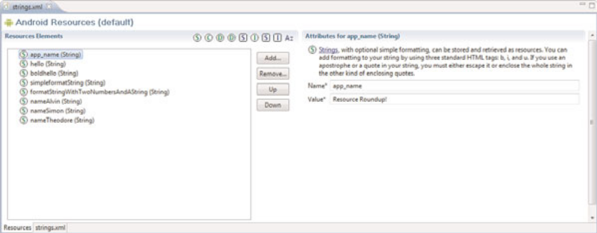

There are two tabs at the bottom of this pane.The Resources tab provides a friendly
method to easily insert primitive resource types such as strings, colors, and dimension resources.
The strings.xml tab shows the raw XML resource file you are creating. Sometimes,
editing the XML file manually is much faster, especially if you add a number of
new resources. Click the strings.xml tab, and your pane should look something like
Figure 6.2.
Figure 6.1 The string resource file in the Eclipse Resource Editor
(Editor view).
Figure 6.2 The string resource file in the Eclipse Resource Editor
(XML

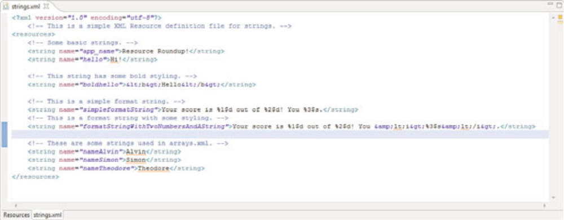

Now add some resources using the Add button on the Resources tab. Specifically, create the following resources:
- A color resource named prettyTextColor with a value of #ff0000
- A dimension resource named textPointSize with a value of 14pt
- A drawable resource named redDrawable with a value of #F00
Now you have several resources of various types in your strings.xml resource file. If you switch back to the XML view, you see that the Eclipse resource editor has added the appropriate
XML elements to your file, which now should look something like this:
<?xml version=”1.0” encoding=”utf-8”?>
<resources>
<string name=”app_name”>ResourceRoundup</string>
<string
name=”hello”>Hello World, ResourceRoundupActivity</string>
<color name=”prettyTextColor”>#ff0000</color>
<dimen name=”textPointSize”>14pt</dimen>
<drawable name=”redDrawable”>#F00</drawable>
</resources>
Save the strings.xml resource file.The Eclipse plug-in automatically generates the
R.java file in your project, with the appropriate resource IDs, which enable you to programmatically access your resources after they are compiled into the project. If you navigate to your R.java file, which is located under the /src directory in your package, it looks something like this:

package com.androidbook.resourceroundup;
public final class R {
public static final class attr {
}
public static final class color {
public static final int prettyTextColor=0x7f050000;
}
public static final class dimen {
public static final int textPointSize=0x7f060000;
}
public static final class drawable {
public static final int icon=0x7f020000;
public static final int redDrawable=0x7f020001;
}
public static final class layout {
public static final int main=0x7f030000;
}
public static final class string {
public static final int app_name=0x7f040000;
public static final int hello=0x7f040001;
}
}
Now you are free to use these resources in your code. If you navigate to your
ResourceRoundupActivity.java source file, you can add some lines to retrieve your resources and work with them, like this:

import android.graphics.drawable.ColorDrawable;
...
String myString = getResources().getString(R.string.hello);
int myColor =
getResources().getColor(R.color.prettyTextColor);
float myDimen =
getResources().getDimension(R.dimen.textPointSize);
ColorDrawable myDraw = (ColorDrawable)getResources().
getDrawable(R.drawable.redDrawable);
Some resource types, such as string arrays, are more easily added to resource files by editing the XML by hand. For example, if we go back to the strings.xml file and choose the strings.xml tab,we can add a string array to our resource listing by adding the following
XML element:
<?xml version=”1.0” encoding=”utf-8”?>
<resources>
<string name=”app_name”>Use Some Resources</string>
<string
name=”hello”>Hello World, UseSomeResources</string>
<color name=”prettyTextColor”>#ff0000</color>
<dimen name=”textPointSize”>14pt</dimen>
<drawable name=”redDrawable”>#F00</drawable>
<string-array name=”flavors”>
<item>Vanilla</item>
<item>Chocolate</item>
<item>Strawberry</item>
</string-array>
</resources>
Save the strings.xml file, and now this string array named “flavors” is available in your source file R.java, so you can use it programmatically in resourcesroundup.java like this:
String[] aFlavors =
getResources().getStringArray(R.array.flavors);
You now have a general idea how to add simple resources using the Eclipse plug-in, but there are quite a few different types of data available to add as resources. It is a common practice to store different types of resources in different files. For example, you might store the strings in /res/values/strings.xml but store the prettyTextColor color resource in /res/values/colors.xml and the textPointSize dimension resource in /res/values/dimens.xml. Reorganizing where you keep your resources in the resource directory hierarchy does not change the names of the resources, nor the code used earlier to access the resources programmatically.
Now let’s have a look at how to add different types of resources to your project.

Working with Resources
In this section,we look at the specific types of resources available for Android applications, how they are defined in the project files, and how you can access this resource data programmatically.

For each type of resource type, you learn what types of values can be stored and in
what format. Some resource types (such as Strings and Colors) are well supported with the Android Plug-in Resource Editor, whereas others (such as Animation sequences) are more easily managed by editing the XML files directly.

Working with Integer Resources
In addition to strings and Boolean values, you can also store integers as resources. Integer resources are defined in XML under the /res/values project directory and compiled into the application package at build time.

Defining Integer Resources in XML
Integer values are appropriately tagged with the <integer> tag and represent a namevalue pair.The name attribute is how you refer to the specific integer programmatically, so name these resources wisely.
Here’s an example of the integer resource file /res/values/nums.xml:
<?xml version=”1.0” encoding=”utf-8”?>
<resources>
<integer name=”numTimesToRepeat”>25</integer>
<integer name=”startingAgeOfCharacter”>3</integer>
</resources>

Using Integer Resources Programmatically
To use the integer resource, you must load it using the Resource class.The following code accesses your application’s integer resource named numTimesToRepeat:
int repTimes = getResources().getInteger(R.integer.numTimesToRepeat);

Working with Colors
Android applications can store RGB color values, which can then be applied to other screen elements.You can use these values to set the color of text or other elements, such as the screen background. Color resources are defined in XML under the /res/values project directory and compiled into the application package at build time. RGB color values always start with the hash symbol (#).The alpha value can be given for transparency control.The following color formats are supported:
- #RGB (example, #F00 is 12-bit color, red)
- #ARGB (example, #8F00 is 12-bit color, red with alpha 50%)
- #RRGGBB (example, #FF00FF is 24-bit color, magenta)
- #AARRGGBB (example, #80FF00FF is 24-bit color, magenta with alpha 50%)
Color values are appropriately tagged with the <color> tag and represent a name-value pair. Here’s an example of a simple color resource file /res/values/colors.xml:
<?xml version=”1.0” encoding=”utf-8”?>
<resources>
<color name=”background_color”>#006400</color>
<color name=”text_color”>#FFE4C4</color>
</resources>
The example at the beginning of the chapter accessed a color resource.Color resources are simply integers.The following code retrieves a color resource called
prettyTextColor:
int myResourceColor =
getResources().getColor(R.color.prettyTextColor);

Working with Dimensions
Many user interface layout controls such as text controls and buttons are drawn to specific dimensions.These dimensions can be stored as resources. Dimension values always end with a unit of measurement tag.
Dimension values are appropriately tagged with the <dimen> tag and represent a namevalue pair. Dimension resources are defined in XML under the /res/values project directory and compiled into the application package at build time.
Here’s an example of a simple dimension resource file /res/values/dimens.xml:
<?xml version=”1.0” encoding=”utf-8”?>
<resources>
<dimen name=”FourteenPt”>14pt</dimen>
<dimen name=”OneInch”>1in</dimen>
<dimen name=”TenMillimeters”>10mm</dimen>
<dimen name=”TenPixels”>10px</dimen>
</resources>
Dimension resources are simply floating point values.The following code retrieves a dimension resource called textPointSize:
float myDimension =
getResources().getDimension(R.dimen.textPointSize);

Working with Simple Drawables
You can specify simple colored rectangles by using the drawable resource type, which can then be applied to other screen elements.These drawable types are defined in specific paint colors,much like the Color resources are defined.

Simple paintable drawable resources are defined in XML under the /res/values
project directory and compiled into the application package at build time. Paintable
drawable resources use the <drawable> tag and represent a name-value pair. Here’s an example of a simple drawable resource file /res/values/drawables.xml:
<?xml version=”1.0” encoding=”utf-8”?>
<resources>
<drawable name=”red_rect”>#F00</drawable>
</resources>

Although it might seem a tad confusing, you can also create XML files that describe other Drawable subclasses, such as ShapeDrawable. Drawable XML definition files are stored in the /res/drawable directory within your project along with image files.This is not the same as storing <drawable> resources, which are paintable drawables. PaintableDrawable resources are stored in the /res/values directory, as explained in the previous section.
Here’s a simple ShapeDrawable described in the file /res/drawable/red_oval.xml:
<?xml version=”1.0” encoding=”utf-8”?>
<shape
xmlns:android=
“http://schemas.android.com/apk/res/android”
android:shape=”oval”>
<solid android:color=”#f00”/>
</shape>
We talk more about graphics and drawing shapes in Chapter 9,“Drawing and Working with Animation.”
Drawable resources defined with <drawable> are simply rectangles of a given color, which is represented by the Drawable subclass ColorDrawable.The following code retrieves a ColorDrawable resource called redDrawable:
import android.graphics.drawable.ColorDrawable;
...
ColorDrawable myDraw = (ColorDrawable)getResources().
getDrawable(R.drawable.redDrawable);

Working with Images
Applications often include visual elements such as icons and graphics.Android supports several image formats that can be directly included as resources for your application
These image formats are all well supported by popular graphics editors such as Adobe Photoshop, GIMP, and Microsoft Paint.The Nine-Patch Stretchable Graphics can be created from PNG files using the draw9patch tool included with the Android SDK under the /tools directory.
Adding image resources to your project is easy. Simply drag the image asset into the /res/drawable directory, and it is automatically included in the application package at build time.

Working with Nine-Patch Stretchable Graphics
Phone screens come in various dimensions. It can be handy to use stretchable graphics to allow a single graphic that can scale appropriately for different screen sizes and orientations or different lengths of text.This can save you or your designer a lot of time in creating graphics for many different screen sizes.
Android supports Nine-Patch Stretchable Graphics for this purpose. Nine-Patch graphics are simply PNG graphics that have patches, or areas of the image, defined to scale appropriately, instead of scaling the entire image as one unit. Often the center segment is transparent.
Nine-Patch Stretchable Graphics can be created from PNG files using the draw9patch tool included with the Tools directory of the Android SDK.

Using Image Resources Programmatically
Images resources are simply another kind of Drawable called a BitmapDrawable. Most of the time, you need only the resource ID of the image to set as an attribute on a user interface control.
For example, if I drop the graphics file flag.png into the /res/drawable directory
and add an ImageView control to my main layout,we can set the image to be displayed programmatically in the layout this way:

import android.widget.ImageView;
ImageView flagImageView =
(ImageView)findViewById(R.id.ImageView01);
flagImageView.setImageResource(R.drawable.flag);

If you want to access the BitmapDrawable object directly, you simply request that resource directly, as follows:

import android.graphics.drawable.BitmapDrawable;
...
BitmapDrawable bitmapFlag = (BitmapDrawable)
getResources().getDrawable(R.drawable.flag);
int iBitmapHeightInPixels =
bitmapFlag.getIntrinsicHeight();
int iBitmapWidthInPixels = bitmapFlag.getIntrinsicWidth();

Finally, if you work with Nine-Patch graphics, the call to getDrawable()returns a
NinePatchDrawable instead of a BitmapDrawable object.

import android.graphics.drawable.NinePatchDrawable;
...
NinePatchDrawable stretchy = (NinePatchDrawable)
getResources().getDrawable(R.drawable.pyramid);
int iStretchyHeightInPixels =
stretchy.getIntrinsicHeight();
int iStretchyWidthInPixels = stretchy.getIntrinsicWidth();

Working with Animation
Android supports frame-by-frame animation and tweening. Frame-by-frame animation involves the display of a sequence of images in rapid succession.Tweened animation involves applying standard graphical transformations such as rotations and fades upon a single image.
The Android SDK provides some helper utilities for loading and using animation resources. These utilities are found in the android.view.animation.Animation Utils class.
Defining and Using Frame-by-Frame Animation Resources
Frame-by-frame animation is often used when the content changes from frame to frame. This type of animation can be used for complex frame transitions—much like a kid’s flip-book.
To define frame-by-frame resources, take the following steps:
1. Save each frame graphic as an individual drawable resource. It may help to name your graphics sequentially, in the order in which they are displayed—for example, frame1.png, frame2.png, and so on.
2. Define the animation set resource in an XML file within /res/drawable/ resource
directory.
3. Load, start, and stop the animation programmatically.

Here’s an example of a simple frame-by-frame animation resource file
/res/drawable/juggle.xml that defines a simple three-frame animation that takes 1.5
seconds:
<?xml version=”1.0” encoding=”utf-8” ?>
<animation-list
xmlns:android=”http://schemas.android.com/apk/res/android”
android:oneshot=”false”>
<item
android:drawable=”@drawable/splash1”
android:duration=”50” />
<item
android:drawable=”@drawable/splash2”
android:duration=”50” />
<item
android:drawable=”@drawable/splash3”
android:duration=”50” />
</animation-list>
Frame-by-frame animation set resources defined with <animation-list> are represented by the Drawable subclass AnimationDrawable.The following code retrieves an Animation- Drawable resource called juggle:
import android.graphics.drawable.AnimationDrawable;
...
AnimationDrawable jugglerAnimation = (AnimationDrawable)getResources().
getDrawable(R.drawable.juggle);
After you have a valid AnimationDrawable, you can assign it to a View on the screen and use the Animation methods to start and stop animation.

Defining and Using Tweened Animation Resources
Tweened animation features include scaling, fading, rotation, and translation.These actions can be applied simultaneously or sequentially and might use different interpolators
Tweened animation sequences are not tied to a specific graphic file, so you can write one sequence and then use it for a variety of different graphics. For example, you can make moon, star, and diamond graphics all pulse using a single scaling sequence, or you can make them spin using a rotate sequence.
Graphic animation sequences can be stored as specially formatted XML files in the /res/anim directory and are compiled into the application binary at build time. Here’s an example of a simple animation resource file /res/anim/spin.xml that defines a simple rotate operation—rotating the target graphic counterclockwise four times in place, taking 10 seconds to complete:
<?xml version=”1.0” encoding=”utf-8” ?>
<set xmlns:android
=”http://schemas.android.com/apk/res/android”
android:shareInterpolator=”false”>
<set>
<rotate
android:fromDegrees=”0”
android:toDegrees=”-1440”
android:pivotX=”50%”
android:pivotY=”50%”
android:duration=”10000” />
</set>
</set>
If we go back to the example of a BitmapDrawable earlier,we can now add some animation simply by adding the following code to load the animation resource file spin.xml and set the animation in motion:

import android.view.animation.Animation;
import android.view.animation.AnimationUtils;
import android.widget.ImageView;
...
ImageView flagImageView =
(ImageView)findViewById(R.id.ImageView01);
flagImageView.setImageResource(R.drawable.flag);
...
Animation an =
AnimationUtils.loadAnimation(this, R.anim.spin);
flagImageView.startAnimation(an);

Now you have your graphic spinning. Notice that we loaded the animation using the base class object Animation.You can also extract specific animation types using the subclasses that match: RotateAnimation, ScaleAnimation, TranslateAnimation, and AlphaAnimation.
There are a number of different interpolators you can use with your tweened animation sequences.

Working with Menus
You can also include menu resources in your project files. Like animation resources, menu resources are not tied to a specific control but can be reused in any menu control.
Each menu resource (which is a set of individual menu items) is stored as a specially formatted XML files in the /res/menu directory and are compiled into the application package at build time.
Here’s an example of a simple menu resource file /res/menu/speed.xml that defines a short menu with four items in a specific order:
<menu xmlns:android
=”http://schemas.android.com/apk/res/android”>
<item
android:id=”@+id/start”
android:title=”Start!”
android:orderInCategory=”1”></item>
<item
android:id=”@+id/stop”
android:title=”Stop!”
android:orderInCategory=”4”></item>
<item
android:id=”@+id/accel”
android:title=”Vroom! Accelerate!”
android:orderInCategory=”2”></item>
<item
android:id=”@+id/decel”
android:title=”Decelerate!”
android:orderInCategory=”3”></item>
</menu>
You can create menus using the Eclipse plug-in, which can access the various configuration attributes for each menu item. In the previous case,we set the title (label) of each menu item and the order in which the items display. Now, you can use string resources for those titles, instead of typing in the strings. For example:
<menu xmlns:android=
“http://schemas.android.com/apk/res/android”>
<item
android:id=”@+id/start”
android:title=”@string/start”
android:orderInCategory=”1”></item>
<item
android:id=”@+id/stop”
android:title=”@string/stop”
android:orderInCategory=”2”></item>
</menu>

To access the preceding menu resource called /res/menu/speed.xml, simply override the method
onCreateOptionsMenu() in your application:
public boolean onCreateOptionsMenu(Menu menu) {
getMenuInflater().inflate(R.menu.speed, menu);
return true;
}
That’s it. Now if you run your application and press the menu button, you see the menu. There are a number of other XML attributes that can be assigned to menu items. For a complete list of these attributes, see the Android SDK reference for menu resources at the website http://d.android.com/guide/topics/resources/menu-resource.html.

Working with XML Files
You can include arbitrary XML resource files to your project.You should store these XML files in the /res/xml directory, and they are compiled into the application package at build time.
The Android SDK has a variety of packages and classes available for XML manipulation.
First, put a simple XML file in /res/xml directory. In this case, the file my_pets.xml
with the following contents can be created:
<?xml version=”1.0” encoding=”utf-8”?>
<pets>
<pet name=”Bit” type=”Bunny” />
<pet name=”Nibble” type=”Bunny” />
<pet name=”Stack” type=”Bunny” />
<pet name=”Queue” type=”Bunny” />
<pet name=”Heap” type=”Bunny” />
<pet name=”Null” type=”Bunny” />
<pet name=”Nigiri” type=”Fish” />
<pet name=”Sashimi II” type=”Fish” />
<pet name=”Kiwi” type=”Lovebird” />
</pets>
Now you can access this XML file as a resource programmatically in the following manner:
XmlResourceParser myPets =
getResources().getXml(R.xml.my_pets);
Finally, to prove this is XML, here’s one way you might churn through the XML and extract the information:
import org.xmlpull.v1.XmlPullParserException;
import android.content.res.XmlResourceParser;
...
int eventType = -1;
while (eventType != XmlResourceParser.END_DOCUMENT) {
if(eventType == XmlResourceParser.START_DOCUMENT) {
Log.d(DEBUG_TAG, “Document Start”);
} else if(eventType == XmlResourceParser.START_TAG) {
String strName = myPets.getName();
if(strName.equals(“pet”)) {
Log.d(DEBUG_TAG, “Found a PET”);
Log.d(DEBUG_TAG,
“Name: “+myPets.
getAttributeValue(null, “name”));
Log.d(DEBUG_TAG,
“Species: “+myPets.
getAttributeValue(null, “type”));
}
}
eventType = myPets.next();
}
Log.d(DEBUG_TAG, “Document End”);

Working with Raw Files
Your application can also include raw files as part of its resources. For example, your application might use raw files such as audio files, video files, and other file formats not supported by the Android Resource packaging tool aapt.
All raw resource files are included in the /res/raw directory and are added to your
package without further processing.

The resource filename must be unique to the directory and should be descriptive because the filename (without the extension) becomes the name by which the resource is accessed.
You can access raw file resources and any resource from the /res/drawable directory (bitmap graphics files, anything not using the <resource> XML definition method). Here’s one way to open a file called the_help.txt:

import java.io.InputStream;
...
InputStream iFile =
getResources().openRawResource(R.raw.the_help);

References to Resources
You can reference resources instead of duplicating them. For example, your application might want to reference a single string resource in multiple string arrays.
The most common use of resource references is in layout XML files, where layouts can reference any number of resources to specify attributes for layout colors, dimensions, strings, and graphics.Another common use is within style and theme resources.
Resources are referenced using the following format:
]resource_type/variable_name Recall that earlier we had a string-array of soup names. If we want to localize the soup listing, a better way to create the array is to create individual string resources for each soup name and then store the references to those string resources in the string-array (instead of the text).

To do this,we define the string resources in the /res/strings.xml file like this:
<?xml version=”1.0” encoding=”utf-8”?>
<resources>
<string name=”app_name”>Application Name</string>
<string name=”chicken_soup”
>Organic Chicken Noodle</string>
<string name=”minestrone_soup”
>Veggie Minestrone</string>
<string name=”chowder_soup”
>New England Lobster Chowder</string>
</resources>
And then we can define a localizable string-array that references the string resources by
name in the /res/arrays.xml file like this:
<?xml version=”1.0” encoding=”utf-8”?>
<resources>
<string-array name=”soups”>
<item>@string/minestrone_soup</item>
<item>@string/chowder_soup</item>
<item>@string/chicken_soup</item>
</string-array>
</resources>
You can also use references to make aliases to other resources. For example, you can alias the system resource for the OK string to an application resource name by including the following in your strings.xml resource file:
<?xml version=”1.0” encoding=”utf-8”?>
<resources>
<string id=”app_ok”>@android:string/ok</string>
</resources>

Working with Layouts
Much as web designers use HTML, user interface designers can use XML to define Android application screen elements and layout.A layout XML resource is where many different resources come together to form the definition of an Android application screen. Layout resource files are included in the /res/layout/ directory and are compiled into the application package at build time. Layout files might include many user interface controls and define the layout for an entire screen or describe custom controls used in other layouts.

The main.xml layout file that displays this screen references a number of other resources, including colors, strings, and dimension values, all of which were defined in the strings.xml, colors.xml, and dimens.xml resource files.The color resource for the screen background color and resources for a TextView control’s color, string, and text size follows:

<?xml version=”1.0” encoding=”utf-8”?>
<LinearLayout xmlns:android=
“http://schemas.android.com/apk/res/android”
android:orientation=”vertical”
android:layout_width=”fill_parent”
android:layout_height=”fill_parent”
android:background=”@color/background_color”>
<TextView
android:id=”@+id/TextView01”
android:layout_width=”fill_parent”
android:layout_height=”fill_parent”
android:text=”@string/test_string”
android:textColor=”@color/text_color”
android:gravity=”center”
android:textSize=”@dimen/text_size”></TextView>
</LinearLayout>
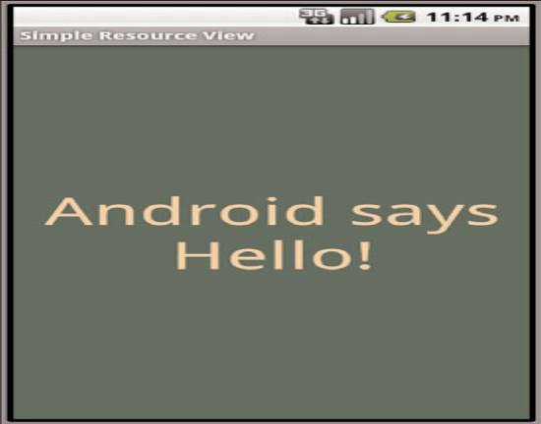

The preceding layout describes all the visual elements on a screen. In this example, a LinearLayout control is used as a container for other user interface controls—here, a single TextView that displays a line of text.

Designing Layouts in Eclipse
Layouts can be designed and previewed in Eclipse using the Resource editor functionality provided by the Android plug-in (see Figure 6.4). If you click the project file /res/layout/main.xml (provided with any new Android project), you see a Layout tab, which shows you the preview of the layout, and a main.xml tab, which shows you the raw XML of the layout file.
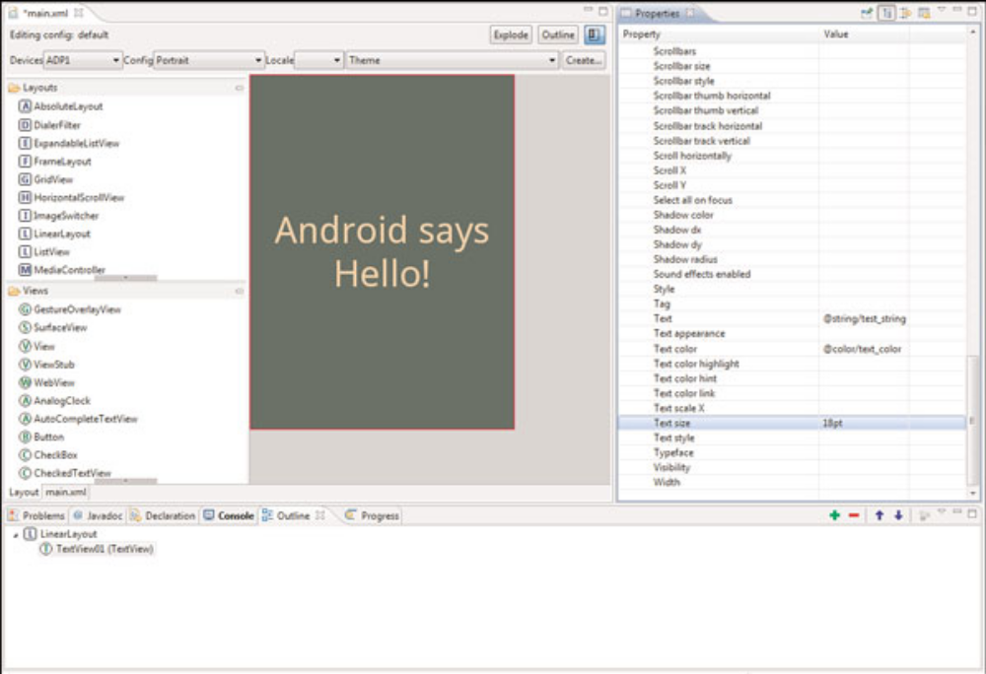
As with most user interface designers, the Android plug-in works well for your basic layout needs, enables you to create user interface controls such as TextView and Button controls easily, and enables setting the controls’ properties in the Properties pane.
Now is a great time to get to know the layout resource designer.Try creating a new Android project called ParisView (available as a sample project). Navigate to the
/res/layout/main.xml layout file and double-click it to open it in the resource editor.
It’s quite simple by default, only a black (empty) rectangle and string of text.
Below in the Resource pane of the Eclipse perspective, you notice the Outline tab.
This outline is the XML hierarchy of this layout file. By default, you see a LinearLayout
If you expand it, you see it contains one TextView control. Click on the TextView control. You see that the Properties pane of the Eclipse perspective now has all the properties available for that object. If you scroll down to the property called text, you see that it’s set to a string resource variable @string/hello.

You can use the layout designer to set and preview layout control properties. For example, you can modify the TextView property called text Size by typing 18pt (a dimension). You see the results of your change to the property immediately in the preview area.

Take a moment to switch to the main.xml tab.You notice that the properties you set
are now in the XML. If you save and run your project in the emulator now, you see similar results to what you see in the designer preview.

Now go back to the Outline pane.You see a green plus and a red minus button.You
can use these buttons to add and remove controls to your layout file. For example, select the LinearLayout from the Outline view, and click the green button to add a control within that container object.

Choose the ImageView object. Now you have a new control in your layout.You can’t actually see it yet because it is not fully defined.

Drag two PNG graphics files (or JPG) into your /res/drawable project directory,
naming them flag.png and background.png.Now, browse the properties of your
ImageView control, and set the Src property by clicking on the resource browser button labeled [...].You can browse all the Drawable resources in your project and select the flag resource you just added.You can also set this property manually by typing @drawable/flag.
Now, you see that the graphic shows up in your preview.While we’re at it, select the LinearLayout object and set its background property to the background Drawable you added.

If you save the layout file and run the application in the emulator (see Figure 6.5) or on the phone, you see results much like you did in the resource designer preview pane.
Using Layout Resources Programmatically
Layouts, whether they are Button or ImageView controls, are all derived from the View class. Here’s how you would retrieve a TextView object named TextView01:

TextView txt = (TextView)findViewById(R.id.TextView01);

You can also access the underlying XML of a layout resource much as you would any XML file.The following code retrieves the main.xml layout file for XML parsing:

XmlResourceParser myMainXml =
getResources().getLayout(R.layout.main);

Developers can also define custom layouts with unique attributes.

Working with Styles
Android user interface designers can group layout element attributes together in styles. Layout controls are all derived from the View base class, which has many useful attributes. Individual controls, such as Checkbox, Button, and TextView, have specialized attributes associated with their behavior.
Styles are tagged with the <style> tag and should be stored in the /res/values/ directory. Style resources are defined in XML and compiled into the application binary at build time.

Here’s an example of a simple style resource file /res/values/styles.xml containing
two styles: one for mandatory form fields, and one for optional form fields on TextView
and EditText objects:
<?xml version=”1.0” encoding=”utf-8”?>
<resources>
<style name=”mandatory_text_field_style”>
<item name=”android:textColor”>#000000</item>
<item name=”android:textSize”>14pt</item>
<item name=”android:textStyle”>bold</item>
</style>
<style name=”optional_text_field_style”>
<item name=”android:textColor”>#0F0F0F</item>
<item name=”android:textSize”>12pt</item>
<item name=”android:textStyle”>italic</item>
</style>
</resources>
Many useful style attributes are colors and dimensions. It would be more appropriate to use references to resources. Here’s the styles.xml file again; this time, the color and text size fields are available in the other resource files colors.xml and dimens.xml:
<?xml version=”1.0” encoding=”utf-8”?>
<resources>
<style name=”mandatory_text_field_style”>
<item name=”android:textColor”
>@color/mand_text_color</item>
<item name=”android:textSize”
>@dimen/important_text</item>
<item name=”android:textStyle”>bold</item>
</style>
<style name=”optional_text_field_style”>
<item name=”android:textColor”
>@color/opt_text_color</item>
<item name=”android:textSize”
>@dimen/unimportant_text</item>
<item name=”android:textStyle”>italic</item>
</style>
</resources>
Now, if you can create a new layout with a couple of TextView and EditText text
controls, you can set each control’s style attribute by referencing it as such:
style=”@style/name_of_style”
Here we have a form layout called /res/layout/form.xml that does that:
<?xml version=”1.0” encoding=”utf-8”?>
<LinearLayout
xmlns:android=
“http://schemas.android.com/apk/res/android”
android:orientation=”vertical”
android:layout_width=”fill_parent”
android:layout_height=”fill_parent”
android:background=”@color/background_color”>
<TextView
android:id=”@+id/TextView01”
style=”@style/mandatory_text_field_style”
android:layout_height=”wrap_content”
android:text=”@string/mand_label”
android:layout_width=”wrap_content” />
<EditText
android:id=”@+id/EditText01”
style=”@style/mandatory_text_field_style”
android:layout_height=”wrap_content”
android:text=”@string/mand_default”
android:layout_width=”fill_parent”
android:singleLine=”true” />
<TextView
android:id=”@+id/TextView02”
style=”@style/optional_text_field_style”
android:layout_width=”wrap_content”
android:layout_height=”wrap_content”
android:text=”@string/opt_label” />
<EditText
android:id=”@+id/EditText02”
style=”@style/optional_text_field_style”
android:layout_height=”wrap_content”
android:text=”@string/opt_default”
android:singleLine=”true”
android:layout_width=”fill_parent” />
<TextView
android:id=”@+id/TextView03”
style=”@style/optional_text_field_style”
android:layout_width=”wrap_content”
android:layout_height=”wrap_content”
android:text=”@string/opt_label” />
<EditText

android:id=”@+id/EditText03”
style=”@style/optional_text_field_style”
android:layout_height=”wrap_content”
android:text=”@string/opt_default”
android:singleLine=”true”
android:layout_width=”fill_parent” />
</LinearLayout>
The resulting layout has three fields, each made up of one TextView for the label and one EditText where the user can input text.The mandatory style is applied to the mandatory label and text entry.The other two fields use the optional style.The resulting layout would look something like Figure 6.6.
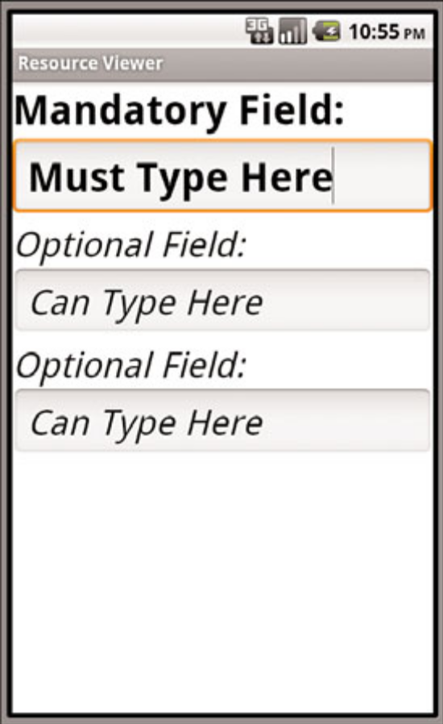

Using Style Resources Programmatically
Styles are applied to specific layout controls such as TextView and Button objects. Usually, you want to supply the style resource id when you call the control’s constructor. For example, the style named myAppIsStyling would be referred to as
R.style.myAppIsStyling.

Working with Themes
Themes are much like styles, but instead of being applied to one layout element at a time, they are applied to all elements of a given activity (which, generally speaking, means one screen).
Themes are defined in exactly the same way as styles.Themes use the <style> tag and should be stored in the /res/values directory.The only difference is that instead of applying that named style to a layout element, you define it as the theme attribute of an activity in the AndroidManifest.xml file.

Referencing System Resources
You can access system resources in addition to your own resources.The android package contains all kinds of resources, which you can browse by looking in the android.R subclasses. Here you find system resources for
- Animation sequences for fading in and out
- Arrays of email/phone types (home,work, and such)
- Standard system colors
- Dimensions for application thumbnails and icons
- Many commonly used drawable and layout types
- Error strings and standard button text
- System styles and themes
You can reference system resources the same way you use your own; set the package name to android. For example, to set the background to the system color for darker gray, you set the appropriate background color attribute to @android:color/darker_gray.
You can access system resources much like you access your application’s resources. Instead of using your application resources, use the Android package’s resources under the android.R class.
If we go back to our animation example,we could have used a system animation instead of defining our own. Here is the same animation example again, except it uses a system animation to fade in:
import android.view.animation.Animation;
import android.view.animation.AnimationUtils;
import android.widget.ImageView;
...
ImageView flagImageView =
(ImageView)findViewById(R.id.ImageView01);
flagImageView.setImageResource(R.drawable.flag);
...
Animation an = AnimationUtils.
loadAnimation(this, android.R.anim.fade_in);
flagImageView.startAnimation(an);

